ANNOUNCEMENT
Rotary District 6220 Global Grant Scholarship

ACADEMIC YEAR 2024-2025

About the Scholarship
The Rotary District 6220 Global Scholar Program awards a $30,000 scholarship for graduate studies (not a doctorate) at a qualified college/university that directly relates to at least one of The Rotary Foundation’s Areas of Focus (see below).
- For U.S. citizens, the graduate program must be outside of the USA.
- For international citizens (i.e., for those who do not have U.S. citizenship or a green card or are not in the process of applying for U.S. citizenship), the graduate program must be outside their native country.
Scholars must commence studies no earlier than the beginning of the academic year in the fall of 2024 and expend the scholarship funds by no later than December 31, 2025.

Eligible applicants will have a demonstrated record of high academic achievement; a reasonable level of proficiency in the language of the region of study; excellent leadership skills and potential; a proven record of success in his or her academic field or vocation; a commitment to community service; well-defined and realistic goals; concrete ideas for advancing within his or her chosen field; and, sincerity about maintaining a lifelong relationship with Rotary after the scholarship period.

Required Areas of Focus
The Rotary Foundation (TRF) focuses its programs on seven global priorities that are most relevant to Rotarians. To be eligible for a Rotary District 6220 Global Grant Scholarship, applicants must have a background, intent to study, and future career plans in at least one of the Areas of Focus below. Pursuing a career in an Area of Focus means the scholar has a long-term commitment to measurable, sustainable change in that area.
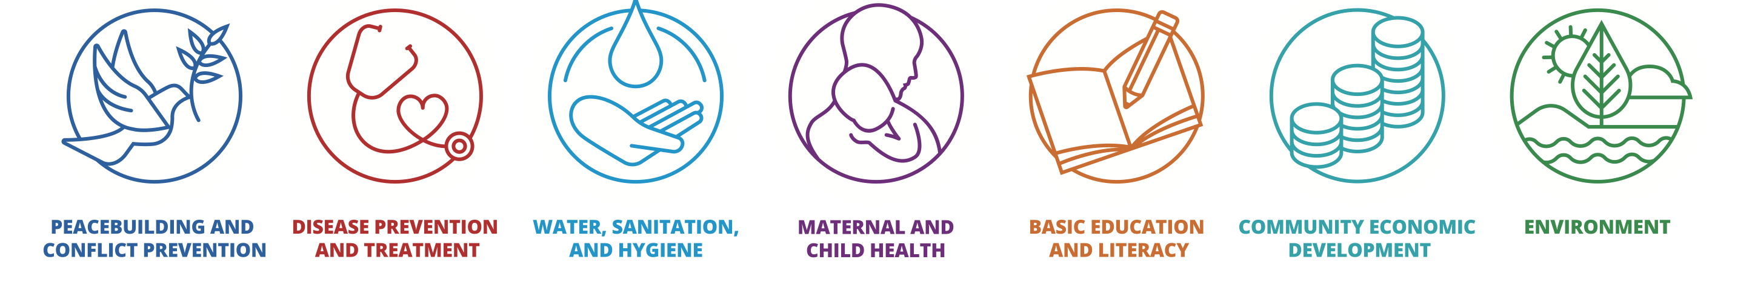
For important information about the seven Areas of Focus: Visit Rotary District 6220 Global Grant Scholarship and scroll down to IMPORTANT GLOBAL GRANT SCHOLARSHIP INFORMATION, then click on “Rotary International Areas of Focus Policy Statement—Elements of Successful Scholarships.”

Scholarship Pre-Qualification Requirements:

Eligible candidates must meet ALL of the following requirements:
- Has (1) previous work experience, volunteer experience and/or education; (2) intended graduate degree studies; AND (3) future career plans that are related to one of the seven Areas of Focus established by Rotary International.
- Plans to enroll in a graduate (not doctorate) level program commencing no earlier than the beginning of the academic year in the fall of 2024 and commits to expending the awarded funds by December 31, 2025.
- Plans to study at an institution located in a geographic area that has a Rotary presence. (There are 34,000 Rotary clubs within 530 Rotary districts around the world. Despite this extensive reach, there are some parts of the world that do not have a formal Rotary presence due to security, safety or other issues. To find Rotary locations, see the Rotary Club Finder website).
- Is NOT (1) a Rotarian; (2) an employee of a club, district, or other Rotary entity, or of Rotary International; (3) the spouse, a lineal descendant (child or grandchild by blood or stepchild legally adopted or not), the spouse of a lineal descendant, or an ancestor (parent or grandparent by blood) of any person who has been in the foregoing two categories within the past three years.
- Currently works in, attends school in, is a resident of, or has a permanent mailing address within District 6220 (which spans northeastern Wisconsin and all but the eastern two counties of the upper peninsula of Michigan). Please refer to District 6220 Area Maps links below under “Important Global Grant Scholarship Information.”
- Has, or will have, sufficient funds to cover any expenses throughout the scholarship time that exceed US $30,000.
- Commits to participating in a humanitarian project sponsored by the host Rotary club in the study region.
- Will attend an orientation and work with a designated Global Grant Scholar mentor to prepare for the program before traveling.
- Agrees to report experiences bi-weekly on an internet blog/platform throughout the scholarship period.
- Agrees to complete all required reports during and after the scholarship time.
- Agrees to make a presentation about the scholarship experience to at least two Rotary clubs within one year after the completion of the scholarship program.

DATE | PROCESS STEP
November 1, 2023 | "Pre-Qualification Application” available for applicants
January 31, 2024 | Deadline to submit “Pre-Qualification Application”
February 1-15, 2024 | Application Review, Finalists Selected
February 15, 2024 | Finalists notified to complete “Full Application”
March 15, 2024 | Deadline for Finalist submission of “Full Application”  - Full Application  - Personal Letter of Introduction  - Academic Transcript(s)  - Two Reference Letters attesting to the candidate’s potential  - Conditional notice of acceptance from chosen international college/university
April 13, 2024 | Scheduled interviews with Finalist(s)
April 13, 2024 | Notification of Global Grant Scholarship Award

Note: District 6220 will not, in any circumstance, review incomplete applications nor waive the requirement for an in-person or virtual interview.

CONTACT INFORMATION

Eric Giordano
District 6220 Scholarship Chair
385.223.0942
egiordano@uwsa.edu

